Mindflash Toolbar for Office

This add-in toolbar for Microsoft Word helps you create web pages, quizzes, and surveys that you can easily add to your coursehost.com courses.

Your learners will only need a web browser to take the courses and answer the questions.

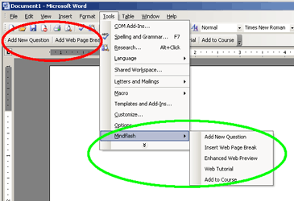
Red bubble: Mindflash Toolbar for Office
Green bubble: Mindflash entries in the menu bar.

Try it!

- Modify this document and save a copy under My Documents.

- Click on Add a file from your computer in the Course & Lesson Builder and upload this document.

- The three Web Page Breaks will cause the document to separate into two web pages, one quiz, and one survey.

True/False Quiz Question: 10 Points

The capital of California is San Francisco.



True

False

Drag and Drop Quiz Question: 10 Points
Instructions for You: Leave the movable images/labels (marked with a blue border) where you want Learners to place them

Can you put these cities on the map?

Drag the labels with the city name to the correct spot on the map.

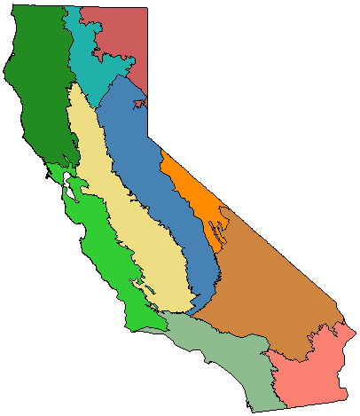
Los Angeles
San Diego
San Francisco

Multiple Choice Survey Question

How informative was this course?

Very informative

Somewhat informative

I already knew most of the material

True/False Survey Question

It was easy to navigate the course.

True

False

Multiple Choice Survey Question

The quizzes in the course were:

Too hard

Appropriate

Way too easy

Fill-in-the-Blank Survey Question
Instructions for You: Add one or more fill-in-the-blank textboxes and type possible answers (separated by semicolons) in each textbox

Complete the sentence by typing your answers into the textboxes.

The best thing about this training course was:
The worst thing about this training course was:

